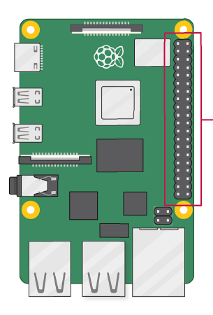

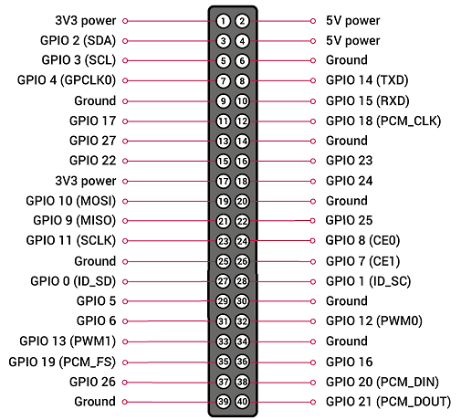RPi 3 Connections (as viewed with USB ports below and power / hdmi ports to the left):

3V3 Pin on ESP8266 -> 3V3 POWER---------------------  
  
Button 3 -> GPIO 2------------------------------------------  
  
Button 1 -> GPIO 3------------------------------------------  
Ground <- Neopixel GND (black wire)  
  
GPIO 14 <- Button 4  
  
GPIO 15 <- Button 2  
  
  
  
  
  
GPIO 23 <- Button 5  
  
  
  
Ground <- System GND  
  
GPIO 25 <- D1 on ESP8266  
  
  
ESP8266 GND -> GND-------------------------------------  
  
  
  
D3 on ESP8266 -> GPIO 5---------------------------------  
  
D2 on ESP8266 -> GPIO 6---------------------------------  
  
  
  
  
  
D0 on ESP8266 -> GPIO 26--------------------------------

GREEN = RPi Pinout, BLACK = Corresponding connection



RPi 3 Connections (as viewed with USB ports above and power / hdmi ports to the right):

GPIO 26 -> D0 on ESP8266  
  
  
  
  
  
GPIO 6 -> D2 on ESP8266  
  
GPIO 5 -> D3 on ESP8266   
  
  
  
GND -> ESP8266 GND  
  
  
D1 on ESP8266 <- GPIO 25--------------------------------  
  
System GND <- Ground-----------------------------------  
  
  
  
Button 5 <- GPIO 23----------------------------------------  
  
  
  
  
  
Button 2 <- GPIO 15----------------------------------------  
  
Button 4 <- GPIO 14----------------------------------------  
  
Neopixel GND (black wire) <- Ground-------------------  
GPIO 3 -> Button 1  
  
GPIO 2 -> Button 3  
  
3V3 POWER -> 3V3 Pin on ESP8266

GREEN = RPi Pinout, BLACK = Corresponding connection

ESP8266 Connections

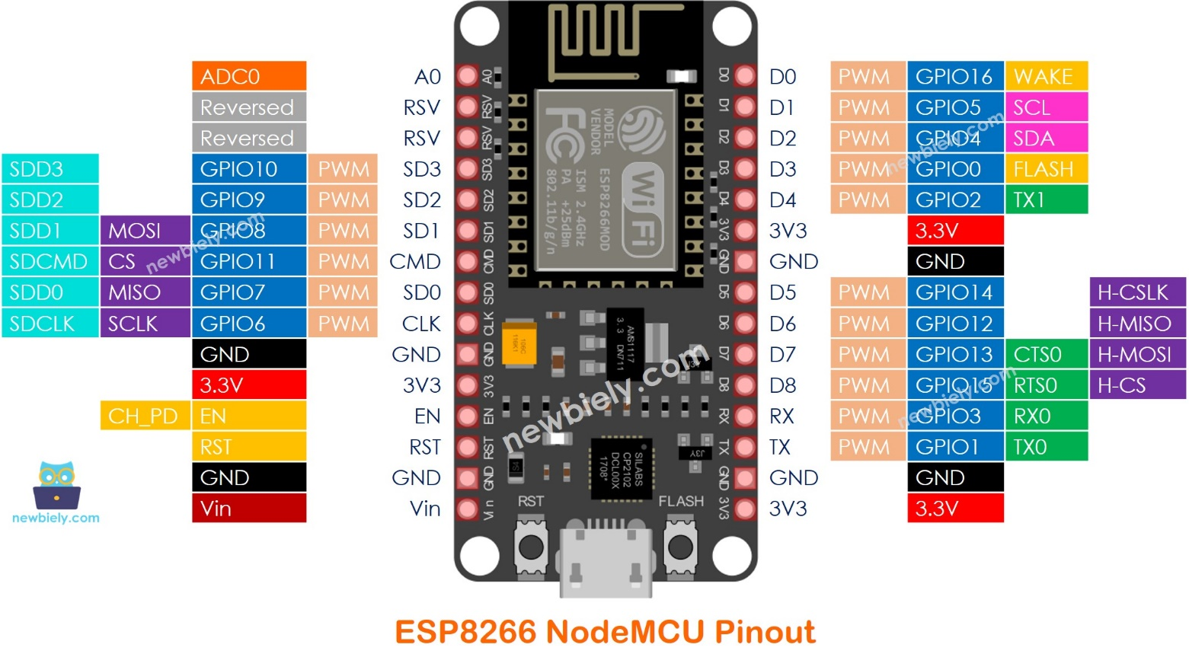

-> RPi GPIO26  
  
-> RPi GPIO25  
  
-> RPi GPIO6  
  
-> RPi GPIO5  
  
  
  
  
  
  
  
  
  
  
  
  
  
  
  
  
  
  
GND--------------------------------------------------------------  
  
RPI 3V3 Pin------------------------------------------------------

Arduino MEGA Connections

(very simple, doesn’t really need a diagram)  
Digital 7 -> Neopixel signal wire (green wire)  
Vin -> Stepper Motor HAT 5V pin  
GND -> ground  
  
BLUE = Arduino Pinout, BLACK = Corresponding connection

Stepper Motor HAT

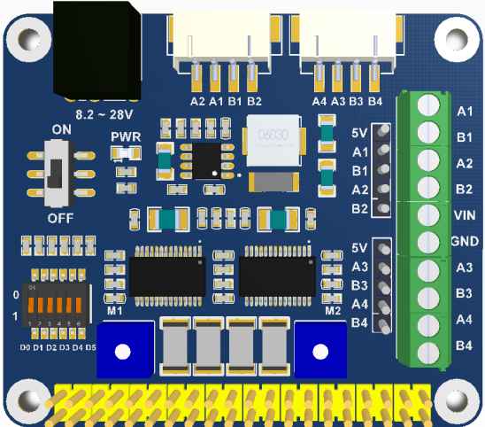  
For A1-4 and B1-4, just use these two white connectors at the top, the Nema 17 motors connect to these directly.  
  
8.2 ~ 28V Vin -> 12V, 5A wall plug power supply

A1,B1,A2,B2 -> horizontal stepper motor  
5V -> Arduino Vin  
  
  
  
  
  
A3,B3,A4,B4 -> vertical stepper motor  
5V -> neopixel Vin (red wire)

ORANGE = HAT Pinout, BLACK = Corresponding connection

Neopixel Pinout  
(simple, no diagram needed)

Vin (red wire) -> 5V HAT Pin  
Data In (green wire) -> Arduino D7 Pin  
GND (black wire) -> RPi GND